Core Banking – Global Solution Delivery
Baseline Functional Specification
CACHE Payment Processing
Document ID | CACHE Payment Processing BFS
Process | Analysis / Design
Status | Working Draft  Under Peer Review  Approved
Date Last Updated | 08/06/2015

Table of Contents
1 Overview 3
1.1 Purpose 3
1.2 Definitions 3
1.3 Related References 3
2 Introduction 4
2.1 Overview 4
2.2 Diagram Overview 4
2.3 Scope 4
2.4 Assumptions 5
2.5 Exclusions 5
2.6 Regulatory Requirements 5
3 Business Functional System Specification 6
3.1 Function #1 6
3.2 Function #2 6
4 Screens 7
4.1 Screen References 7
4.2 Screen Flow Diagram 7
5 Letters / Notices 8
5.1 Letter / Notice References 8
5.2 Letter / Notice Flow Diagram 8
6 Reports 9
6.1 Report References 9
7 PCD / Parameter Tables 10
7.1 PCD / Parameter Table References 10
8 Interfaces 11
8.1 Online 11
8.2 Batch 11
9 Testing Considerations 12
9.1 Hints and Tips 12
10 Summary of Amendments 13
11 <Template Version and Administration> 14
11.1 Template Version History 14
11.2 Contact Details 14

Overview

Purpose
The purpose of this document is to provide a hierarchical view of a system’s business functionality. The view is composed of several levels, each level representing a decomposition of the one above and showing more detailed functionality. Within the baseline, each group represents a discrete set of functions, with each belonging to one and only one grouping.
This is a living reference document, which needs to be updated for changes / enhancements made to the function(s) described within.
Refer to the Baseline Documentation page via PVCS for guidelines on how to update this document and for a description of the Baseline Documentation Process.

Definitions
The Core Banking (CB) Glossary of Terms is available as a link from the Sharepoint Max site.
http://sharepoint.apps.anz/teams/CBBT/Lists/Glossary/Sorted.aspx

Related References
Document | Description
CACHE Codes Manual | Documents found on X:\Project\CACHE_Orion\Baseline Documentation\CACHE\BFS
CACHE Error Codes | Documents found on X:\Project\CACHE_Orion\Baseline Documentation\CACHE\BFS
CACHE Screens Manual | Documents found on X:\Project\CACHE_Orion\Baseline Documentation\CACHE\BFS
Sub-product Definitions | Documents found on X:\Project\CACHE_Orion\Product Definitions\Deposits

Introduction

Overview
This document represents an overview of CACHE Payment Processing via both CACHE Online (DBD$ screen) and batch (value file from CTM). It also explains the use of OBP Codes within CACHE Payment Processing.

Diagram Overview
The following diagram depicts the types of payment processing to and within the CACHE system.
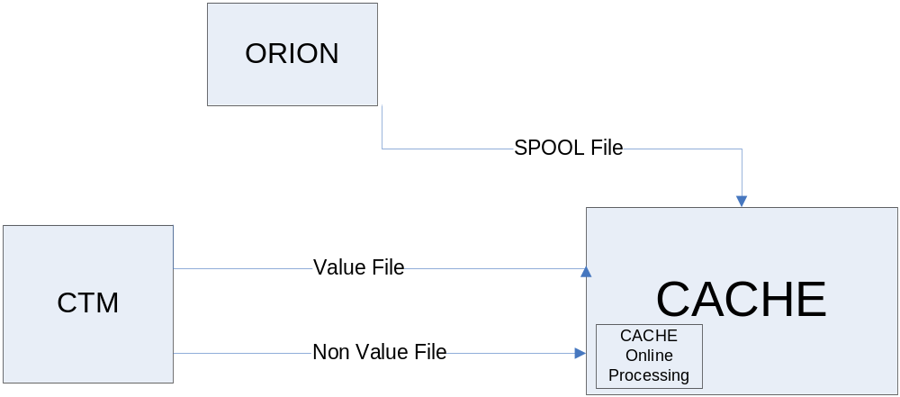

Scope
The scope of this baseline document includes the following aspects of payment processing with the CACHE System;
- Float Processing (Non-value transactions from CTM)
- Available Funds processing
- Uncleared Funds Tolerance Threshold
- OBP Codes
- Transaction processing via DBD$ screen
- Transaction processing via batch
- Payment validations

Assumptions
None

Exclusions
- All payment processing other than that directly associated with RUFL. Other Payment processing information to be added at a later stage as a Baseline Document update.

Regulatory Requirements
- This section is not applicable to Payment Processing

Business Functional System Specification

Float Processing (Non-value transactions from CTM)
Deposit Processing
The following section refers to processing of credit transactions from CTM to CACHE.
- Any transactions (regardless of the source) in the non-value file received from CTM which has an associated float amount is processed as uncleared funds against the account on CACHE.
- All transactions in the value file are processed as cleared funds.

Float Processing
The following section refers to processing of non value transactions with float amounts from CTM.
- The non-value file from CTM contains float amount and days up to 5 days for all applicable transactions. The float amount and float day are determined by CTM before the transaction is sent to CACHE. The non value transactions with float amount and days are processed as follows:
  - A non-value transaction item is created in CACHE using the 2 non-value Tran codes (1228 & 1229). The item is used to update the following:
    - Transaction history of the account (Refer heading “Transaction History” in this section).
    - CR5149 Transaction Posting Journal.
    - Current Collected Balance stored on DDMU field 08 (Posting Fields).
    - Collected Balance for the day stored on DDMU field 68 (Account Balance History – Days 1-30).
    - All relevant fields on DDMU field 09 (Year-To-Date Aggregate Fields) and 77 (Month-To-Date Balance Information).
    - Relevant Float Day field on DDMU field 06 (Float Fields).
    - Relevant Float amount and Day information on IDSR>DD18.
- On the CACHE>HSSR>ABAL (available balance) screen, field called UNCOLLECTED BALANCE reflects the total amount of float for a particular account.
- If a non value float transaction received has got multiple float day information, it is treated as a single transaction with multiple float days. For e.g. a transaction processed by the front line involved multiple cheques with different float days and is sent to CACHE as a single non value transaction, then it is displayed in transaction history once but updates multiple float day fields on DDMU field 06.
- Also note that the CTM non value file can contain float transactions with negative amounts. Such float transactions are processed the same way as described above.

The following section refers to handling of non value transactions with float that get rejected in CACHE during nightly batch.
- Reject non value float transactions to OTP for the following reasons:
  - Invalid Account status, for e.g. Account with status 07 or 08
  - Accounts with Stopped Account restriction loaded
  - Any existing rules to reject value transactions
- The reject float item appears on CR5161 Rejected Items report.
  - The transaction amount is always zero and does not reflect in the totals at the end of each officer.
  - The transaction is identified with a type F, which is displayed in place of a C or D
- The item appears on the SR0005 OTP Input List Report.
  - The transaction amount is always zero.
  - The transaction is identified with a type F, which is displayed in place of a C or D
- The item appears in CACHE>OTPR screen with the DISPOSITION of REJ, relevant float details and the reason for reject as displayed in figures 1.1A & 1.2A.

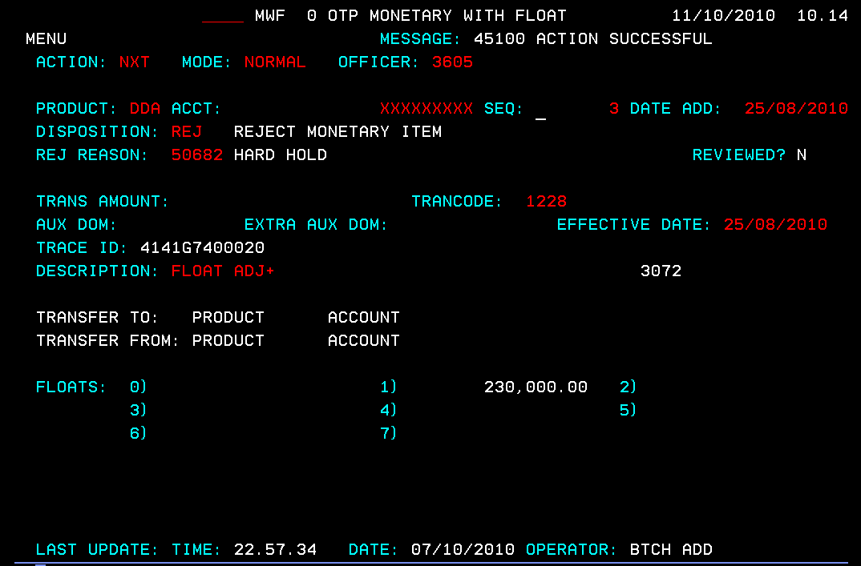
Figure 1.1A: OTPR non value Float Adj+ item in CACHE

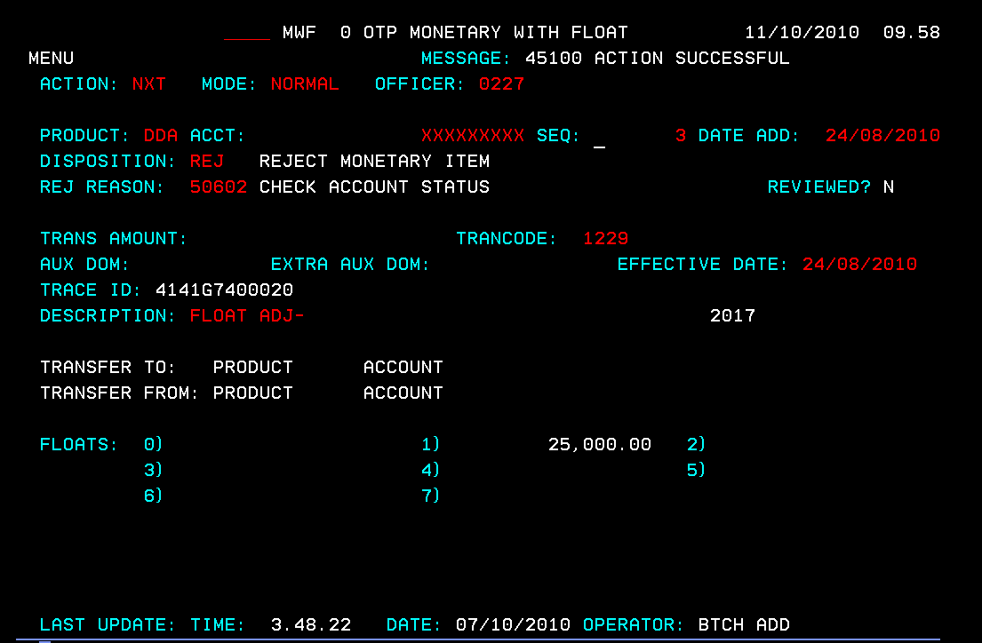
Figure 1.2A: OTPR non value Float Adj- item in CACHE
  - If the user tries to change the DISPOSITION to anything other than REJ, then error “3314 Disposition Not Allowed” is displayed.
    - Once the item has cleared from OTP, the user is required to manually adjust the float on the account using the DD18 screen on CACHE.
    - The OTP item then appears on the SR0002 Items not to be Reprocessed report the following day.
  - The transaction amount is always zero.
  - The transaction is identified with a type F, which is displayed in place of a C or D

Float Adjustments
The following section refers to processing of float adjustments via the CACHE DD18 screen.
- After the user enters all relevant details on DD18, the user presses enter to process the adjustment. Once validations for all fields on DD18 have passed the following takes place:
  - Shadow post non-value transaction to CTM
- After the transaction successfully shadow posts to CTM, the following takes place:
  - Display a confirmation message, “ACTION SUCCESSFUL”

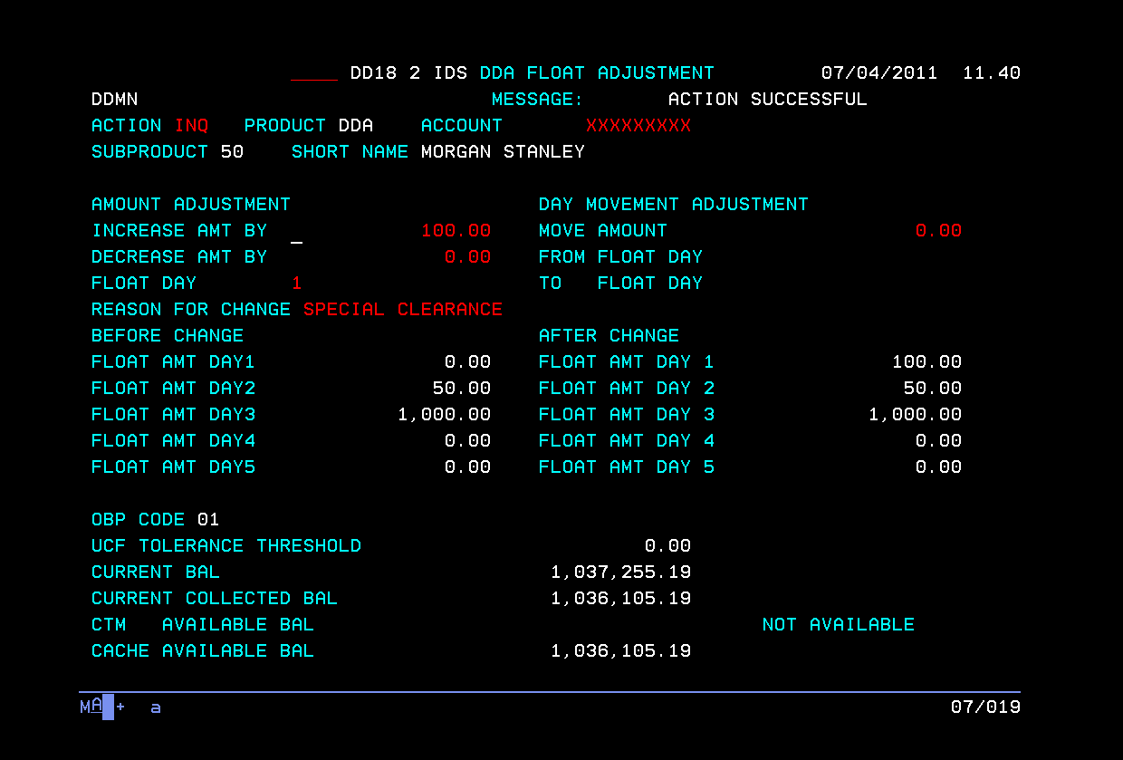
Figure 1.1C: DDA Float Adjustment After Adjustment
  - A non-value transaction for each adjustment is made based on the details entered by the user:
            - For a transaction that results in an increase in the amount of float for a specific day, results in a non-value transaction with Tran code 1228.
            - For a transaction that results in a decrease in the amount of float for a specific day, results in a non-value transaction with Tran code 1229.
  - If the user does a Day Movement Adjustment it results in 2 non-value transactions being posted on the customers account.
            - First transaction for movement (decrease) of float from one day.
            - Second transaction for movement (increase) of float into the other day.
  - Based on details entered by the user, the float on DD18 is adjusted based on the following scenarios:
            - Amount Adjustment (Increase/Decrease) for a specific Float Amount Day (1 to 4).
            - Day Movement Adjustment from one float day to another.
            - After displaying the float adjustment under AFTER CHANGE:
      - When the user does an ACTION of INQ on the same account, the displayed float adjustment moves into the BEFORE CHANGE float fields.
      - The AFTER CHANGE heading and float fields along with the BEFORE CHANGE heading disappear.
  - Updates the COLLECTED BALANCE field based on the float adjustment amount.
  - Displays the updated CACHE AVAILABLE BALANCE
  - Posts non-value transaction on CACHE ONLINE (THFR), transaction history.
  - Displays the updated CTM AVAILABLE BALANCE on DD18
  - Updates the CACHE to CTM refresh file to include the updated float details.
  - Reports the non-value adjustment transaction on CR5225 Online Transaction Posting Journal when posted successfully.
  - Reports the non-value adjustment transaction on CR5149 Transaction Posting Journal when posted successfully.
  - Does not display transaction on Customer Statements.

The following section refers to automatic movement (ageing) of float days and amount via CACHE batch.
- CACHE automatically ages the floats on a daily basis during the nightly batch, i.e. FLOAT DAY 5 to FLOAT DAY 4, FLOAT DAY 4 to 3, FLOAT DAY 3 to 2 and so on.
- CACHE updates the collected balance with the cleared amount held in FLOAT DAY 1 once batch is run.
- The aged float days and amounts are displayed on DD18 screen.
Float Amount Adjustment
- Once the float has aged from one day to another, the daily CACHE to CTM refresh file (during overnight batch) includes all updated float information.
- The following account fields are included on the CACHE to CTM Daily Refresh file (PTOZ.PFILE.RF.CACHE.ACCOUNT) sent to CTM:
    - Float Amount Day 1 – total float amount for day 1.
    - Float Amount Day 2 – total float amount for day 2.
    - Float Amount Day 3 – total float amount for day 3.
    - Float Amount Day 4 – total float amount for day 4.
    - Uncleared Funds Tolerance Threshold Amount: The Uncleared Funds Tolerance Threshold amount is sent based on OBP code as follows:
    - Accounts with OBP code 01, 03, 61 & 81: Max 9’s value
    - Accounts with OBP code 63: 0
    - Accounts with OBP Code 83: Based on Business Unit entry on new PCD 71241.
PCD 1641
The following screen is used to define how a transaction is processed.
- Following entries appear in PCD 1641 for float transaction code:
  - 1228 – used for float transaction increase adjustment.
  - 1229 – used for float transaction decrease adjustment.
- The processing order of transactions during batch is:
  - All credit value transactions then,
  - All float non-value transactions then,
  - All debit value transactions.

Transaction History
The following section refers to SDET screen in Transaction history:
- In the SDET screen for both value transactions and non value float transactions, the “CURR BALANCE AFTER POST” displays the current balance after posting to the account.
- A calculated field called “CURR COLL BAL AFTER POST” is displayed in SDET screen for all transactions. The Collected Balance is calculated as Current Balance minus Float.
The following section refers to display of non value float transactions in Transaction history.
- Transactions with non-value Tran codes 1228 and 1229 are included in CACHE transaction history (THFR) for Option 02 and 03. (Refer Figure 2A & 2B).
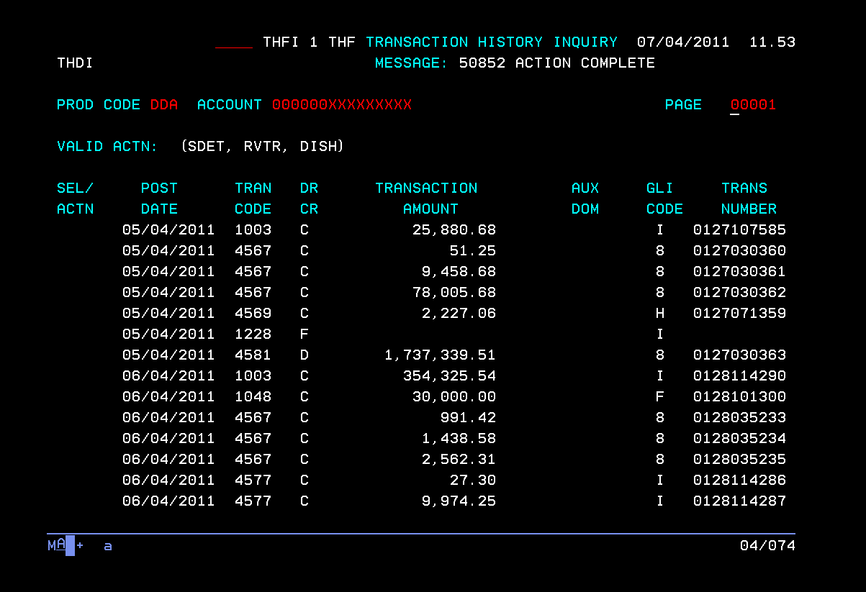
Figure 2A: Transaction History Inquiry – Option 02(Transaction History Inquiry).

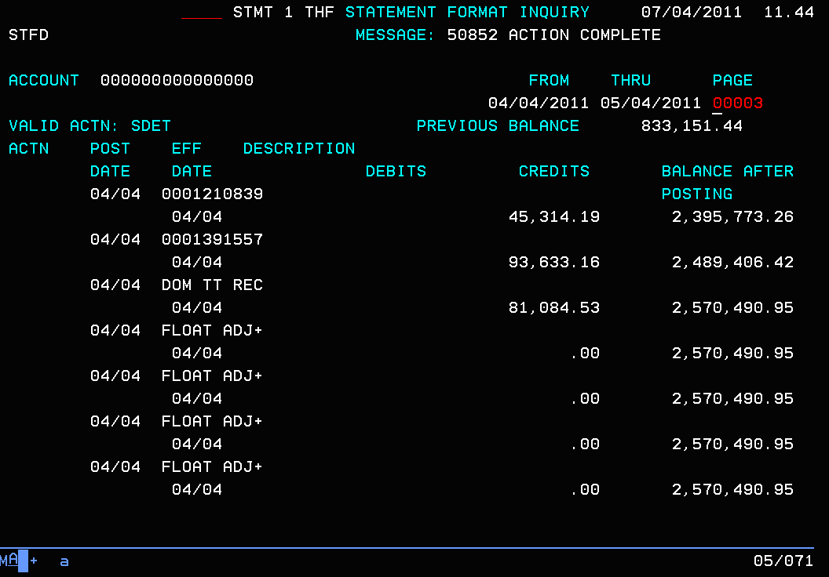
Figure 2B: Transaction History Inquiry – Option 03(Statement Format Inquiry).
- Non value transactions with Tran code 1228 and 1229 are displayed on Single Transaction Detail Inquiry screen when SDET is entered next to transaction under column SEL/ACTN (for THFR Option 02) or VALID ACTN (for THFR Option 03) – Refer Figure 2C.

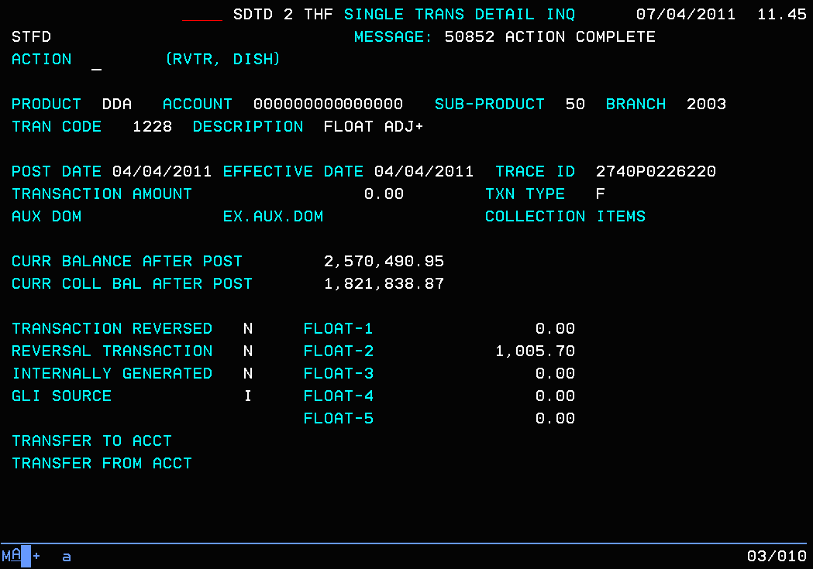
Figure 2C: Indicative Single Transaction Detail Inquiry for Float.
- The TRANSACTION AMOUNT is always 0.00 as this is a non-value transaction.
- The non-value transaction is indicated by an ‘F’ in the TXN TYPE field.
- The Float amount of the non value transactions is displayed in SDET screen. As shown in Figure 2C, the relevant float day field is displayed for a non-value transaction.
- The Float amount associated with the value transaction is displayed under the appropriate float day, in one of Float-1, Float-2, Float-3 or Float-4 fields, determined and sent by CTM in the non value file.
- The Float adjustment amount is displayed under the appropriate float day, in one of Float-1, Float-2, Float-3, Float-4 or Float-5 for float adjustment transaction processed on DD18 screen via CACHE online.
- The float amount for a non-value transaction reflects in the “CURR COLL BAL AFTER POST” field in the SDET screen.
- The float day fields only appear for non value Tran codes 1228 & 1229. For all other transactions that appear in transaction history, the float day fields (0-5) are not displayed.
- The non-value transaction cannot be reconciled back to the value transaction.
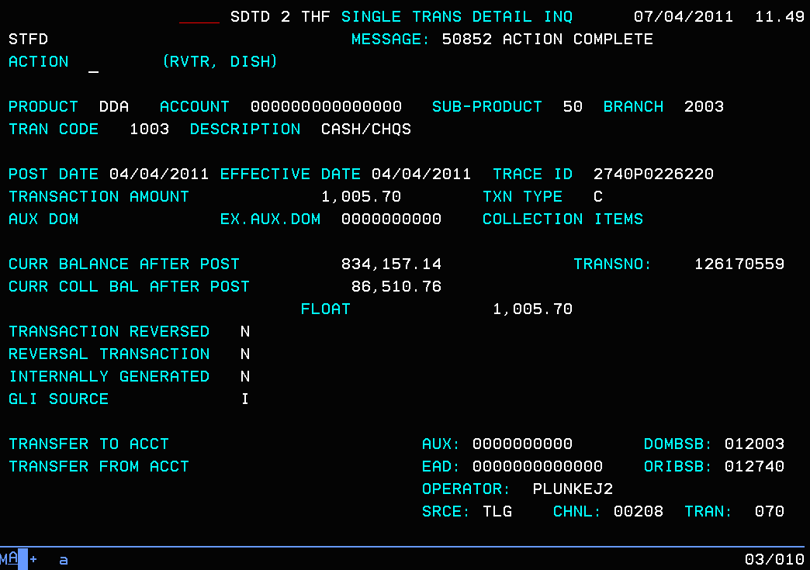
Figure 2D: Indicative Single Transaction Detail Inquiry for Value Transaction.
- The value transaction which has a float amount associated appears in transaction history as displayed in Figure 2D.
- The associated float amount appears under the dynamic field called “FLOAT”. The dynamic float field is displayed even if the float amount associated with the credit value transaction is $0.00. This field is only displayed for batch value credit transactions.
- The float amount if populated for a value transaction does not reflect in the “CURR COLL BAL AFTER POST” field in the SDET screen.

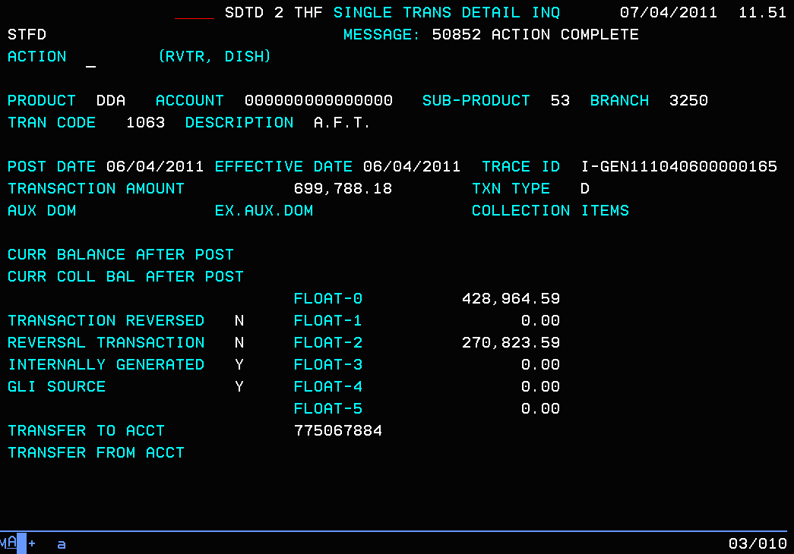
Figure 2E: Indicative Single Transaction Detail Inquiry for Sweep Value Transaction.
- The sweep value transaction which has float moved from originating account to related account or vice versa appears in transaction history as displayed in Figure 2E.
- The float amount moved as a result of the sweep value transaction is displayed under the appropriate float day, in one of Float-0, Float-1, Float-2, Float-3, Float-4 or Float-5 fields.
- As the sweep transaction is the last part of the CACHE batch processing, the display of float movement also takes into account the aging of float (i.e. if the float amount was moved from Float-3, it displays on the sweep value transaction under Float-2).

Reversal of Non-Value Float Adjustment Transactions
- Reversal of non-value float adjustment transactions through Transaction History via RVTR command is blocked.
- If the user attempts to reverse the non-value float adjustment transaction an error “2021 Txn Not Allowed To Be Reversed” appears.
- Reversal for float transaction is completed manually via the DD18 Float Adjustment screen as a new transaction. For e.g. if the user has processed an adjustment in error where the float amount was moved from day 4 to day 2, but should have moved from day 4 to 3, the user can go back to DD18 screen and do another adjustment to move the float amount back one day, i.e. from day 2 to day 3.

OBP Codes
The following section details the valid OBP Codes in CACHE, the calculation used for Available Balance and the context in which they are used.
OBP Code for Batch Processing
01: Pay all using Ledger Balance
Available Balance = Ledger Balance + OD Limit,
Post all Transaction to account. Do not report
03: Pay up to the limit using Ledger Balance
Available Balance = Ledger Balance + OD Limit,
Reject Transactions exceeding Available Balance & Report
61: Pay all using Collected Balance
Available Balance = Collected Balance + OD Limit
Collected Balance = cleared funds
Post all Transactions & Report
63: Pay up to the limit using Collected Balance
Available Balance = Collected Balance + OD Limit
Reject Transactions exceeding Available Balance & Report
81: Pay all using Collected Balance + Uncleared Funds Tolerance Threshold
Available Balance = Collected Balance + OD Limit + Uncleared Funds Tolerance Threshold
Post all Transactions & Report
83: Pay up to the limit using Collected Balance + Uncleared Funds Tolerance Threshold
Available Balance = Collected Balance + OD Limit + Uncleared Funds Tolerance Threshold
Reject Transactions exceeding Available Balance & Report

OBP Code for Online Enquiry
01: Pay all using Ledger Balance
Available Balance = Ledger Balance + OD Limit,
03: Pay up to the limit using Ledger Balance
Available Balance = Ledger Balance + OD Limit,
61: Pay all using Ledger Balance + OD Limit
Available Balance = Ledger Balance + OD Limit
Float Allowance is always total Uncollected Balance
63: Pay up to the limit using Collected Balance
Available Balance = Collected Balance + OD Limit
81: Pay all using Ledger Balance + OD limit
Available Balance = Ledger Balance + OD Limit
83: Pay up to the limit using Collected Balance + Uncleared Funds Tolerance Threshold
Available Balance = Collected Balance + OD Limit + Uncleared Funds Tolerance Threshold

OBP Code for Online Posting
01: Pay all using Ledger Balance
Available Balance = Ledger Balance + OD Limit,
Post all transactions even if the amount of the transaction exceeds CTM available balance
03: Pay up to the limit using Ledger Balance
Available Balance = Ledger Balance + OD Limit,
Reject transaction online if the amount of the transaction exceeds the CTM available balance.
61: Pay all
Available Balance = Ledger Balance + OD Limit
Post all transactions even if the amount of the transaction exceeds CTM available balance
63: Pay up to the limit using Collected Balance
Available Balance = Collected Balance + OD Limit
Reject transaction online if the amount of the transaction exceeds the CTM available balance
81: Pay all
Available Balance = Ledger Balance + OD Limit
Post all transactions even if the amount of the transaction exceeds CTM available balance
83: Pay up to the limit using Collected Balance + Uncleared Funds Tolerance Threshold
Available Balance = Collected Balance + OD Limit + Uncleared Funds Tolerance Threshold
Reject transaction online if the amount of the transaction exceeds the CTM available balance

Restricting Account from Accessing Uncleared Funds
Float processing applies to all DDA accounts with the ability to allow unrestricted, restricted or provide partial access to uncleared funds.
- Apart from Sub Products 05, 06 and 99 any accounts attached to all other Sub Product codes can have any valid OBP code loaded.
  - Following existing validations occur while maintaining OBP Code on DD01:
    - For SP 05 (Manager Account), If OBP Code is changed to anything other than 01, an error “207 OBP Code Is Invalid” appears.
    - For SP 06 (Prepaid Interest FDA Manager Account), If OBP Code is changed to anything other than 01, an error “207 OBP Code Is Invalid” appears.
    - For SP 99 (DDA Setoff Group Level Interest), If OBP Code is changed to anything other than 01, an error “207 OBP Code Is Invalid” appears.
- When a deposit with uncleared funds is reversed using RVTR functionality on CACHE Online the following happens:
    - Transaction history is updated.
    - Debit/Credit interest is adjusted automatically.
    - Appropriate float must be adjusted manually via DD18 screen. This is because, due to the ageing of float, the system is unable to identify the float amount associated with the reversed transaction.

Available Funds Processing
Following section refers to the CACHE Available Balance Inquiry Screen accessed via HSSR >Option 01(Account Level Functions)> Option 02 (Available Bal. Incl Taxes Due)

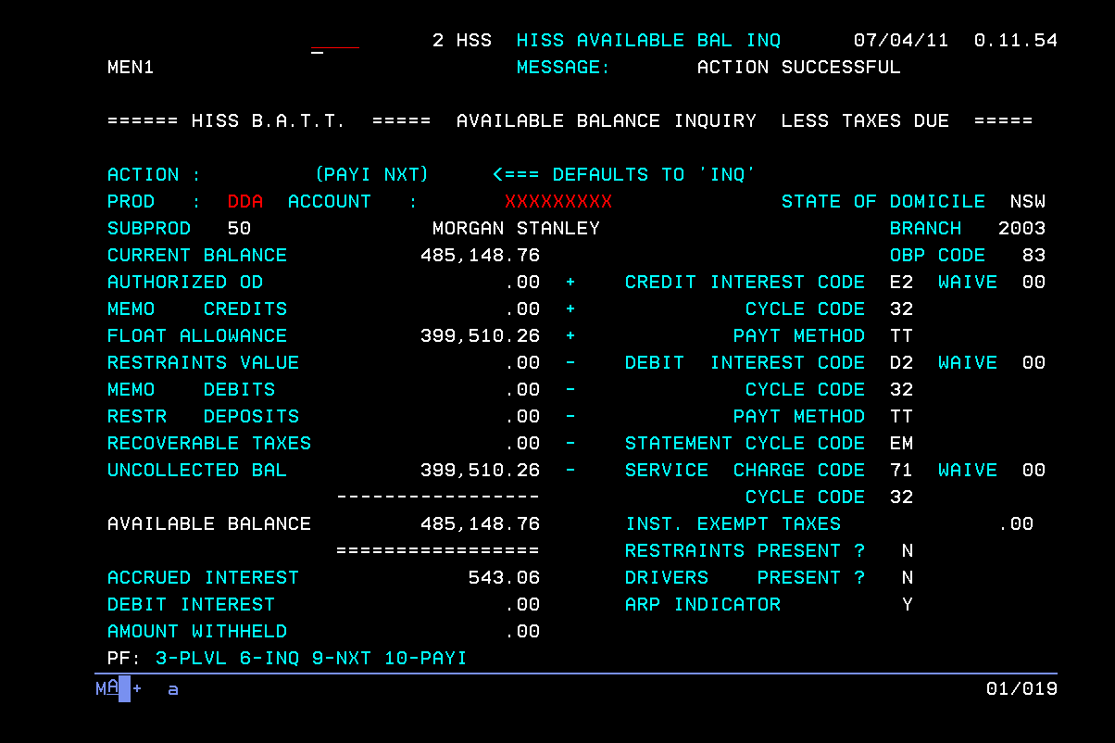
Figure 3A: Proposed Available Balance Inquiry Screen with new Float Allowance field.

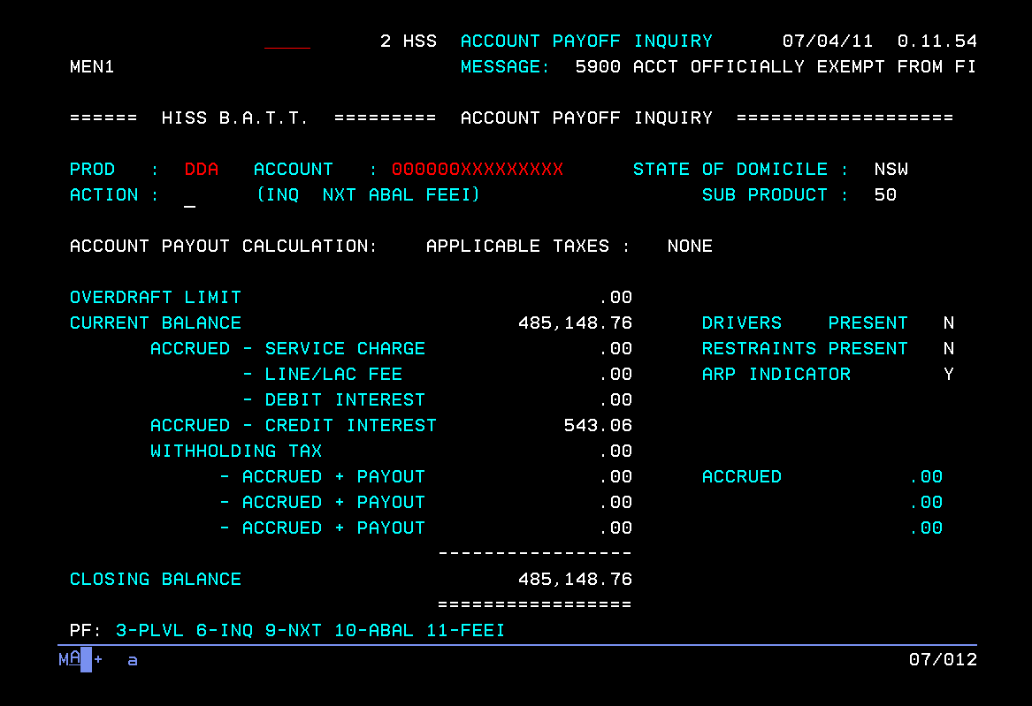
Figure 3.1.1A: Proposed Account Payoff Screen.

- If an account has Uncleared Funds (float) present, it is displayed in Available Balance Enquiry screen under UNCOLLECTED BAL field.
- FLOAT ALLOWANCE field represents the amount of uncleared funds the customer can access.
- FLOAT ALLOWANCE is populated as follows:
  - OBP Code 01 and 03:
- The FLOAT ALLOWANCE always equals the UNCOLLECTED BAL therefore reflecting the client has full access to uncleared funds on the account.
  - OBP Code 61:
- The FLOAT ALLOWANCE always equals the UNCOLLECTED BAL therefore reflecting the client has pay all facility.
  - OBP Code 63:
- The float allowance is always ‘0.00’.
- The UNCOLLECTED BAL represents the total uncleared funds on the account, therefore restricting customer’s access to uncleared funds on the account.
  - OBP Code 81:
- The FLOAT ALLOWANCE always equals the UNCOLLECTED BAL therefore reflecting the client has pay all facility.
  - OBP Code 83:
- The FLOAT ALLOWANCE takes into account the Business Unit Uncleared Funds Tolerance Threshold, therefore allowing the customer to access uncleared funds up to the Uncleared Funds Tolerance Threshold. The following conditions apply:
    - If the Uncleared Funds Tolerance Threshold is greater than uncleared funds amount, the FLOAT ALLOWANCE equals the UNCOLLECTED BAL field.
    - If the Uncleared Funds Tolerance Threshold is equal to uncleared funds amount, the FLOAT ALLOWANCE equals the UNCOLLECTED BAL field.
    - If the Uncleared Funds Tolerance Threshold is less than uncleared funds amount, the FLOAT ALLOWANCE equals the Uncleared Funds Tolerance Threshold, therefore customer does not have access to all the uncleared funds. For e.g. Uncleared Funds Tolerance Threshold = $100.00, Uncleared Funds = $500.00, therefore FLOAT ALLOWANCE = $100.00,
- The UNCOLLECTED BAL represents the total uncleared funds on the account.
- Available Balance is calculated as:
Current Balance + Overdraft Limit + Float Allowance – Uncollected Balance
- The Accrued Interest field, Debit Interest field and Amount Withheld field are displayed under the Available Balance field as they are not included in the available balance calculation.
- Please note that the ABAL screen is not to be used to get pay off figures for account closure. The front line uses HSSR>Option 01>Option 03 (Payoff/Payoff Inquiry) screen.
- The value of Uncleared Funds Tolerance Threshold is extracted from PCD 71241 based on the Business Unit Indicator. The Business Unit Indicator is extracted from PCD 76006.

Business Unit Uncleared Funds Tolerance Threshold
The purpose of the Business Unit Uncleared Funds Tolerance Threshold is to enable the customer to access uncleared funds up to the Threshold. The Business Unit Uncleared Funds Tolerance Thresholds are stored on PCD71241.
- When the Uncleared Funds Tolerance Threshold per Business Unit is changed, all accounts belonging to that Business Unit reference the new Uncleared Funds Tolerance Threshold amount at the start of the effective date controlled by effective date entries on PCD.
- When maintaining the Uncleared Funds Tolerance Threshold per Business unit, the effective date cannot be prior than the next business day.
- Any updates to the Uncleared Funds Tolerance Threshold amount are sent to CTM in the end of day daily refresh file. This Uncleared Funds Tolerance Threshold sent to CTM is for date effective as from next business day.
- If an account is moved from one manager set to another resulting in a change in Business Unit, the new Uncleared Funds Tolerance Threshold is effective only on next business day for online posting. Once an Officer code is amended where the account is referring to a new Business Unit, the batch pay/no pay decision is based on new Uncleared Funds Tolerance Threshold for account with applicable OBP Codes.

Payment Processing & Transfers
The following section refers to transfers and processing of payments via CACHE online and batch.
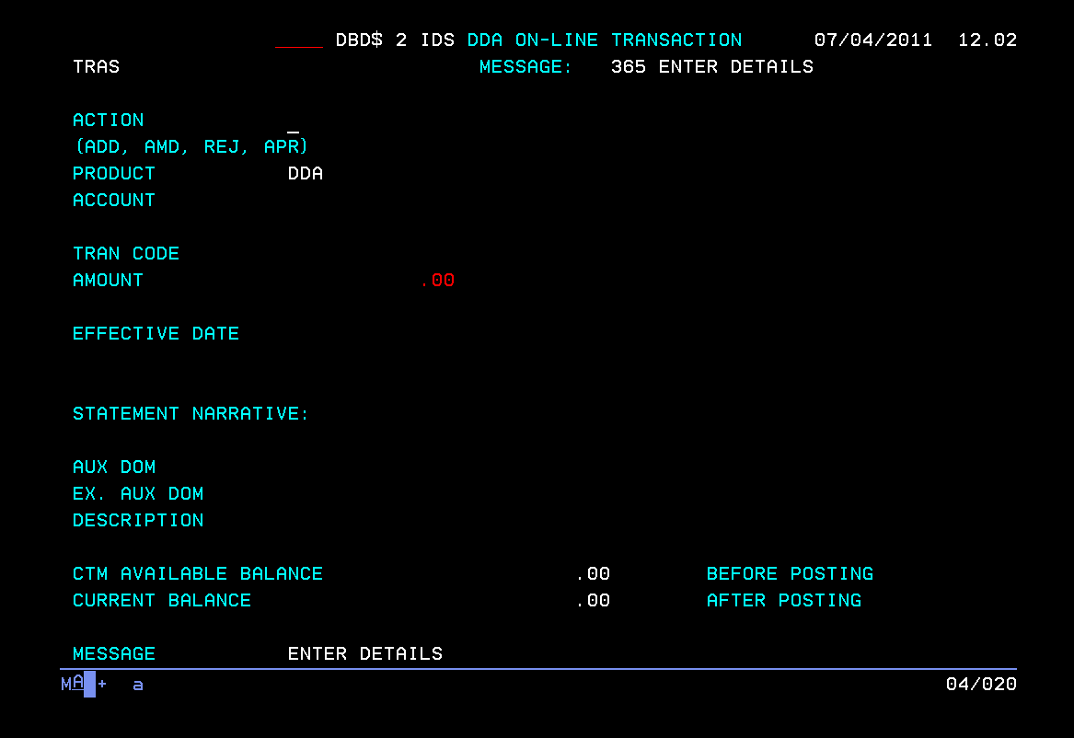
Figure 5A – DBD$ (TRAS) Screen on CACHE
- As shown in Figure 5A, field called “CTM AVAILABLE BALANCE” is displayed on DBD$ screen.
  - This field displays the available balance for the account number entered in the account field.
  - At the time of processing the transaction, when the user presses the enter key, the available balance is obtained from CTM using an MQ query to CTM.
  - The balance displayed does not consider the current transaction amount that is being processed by the user, hence is the before posting balance.
  - As shown in Figure 5A, comment stating “BEFORE POSTING” is displayed.
- When processing a debit transaction or debit portion of a transfer between two CACHE Client accounts via CACHE Online, i.e. CACHE DBD$ and DD17 (Withholding Tax Adjustment) screens, the following occurs:
  - The debit amount is checked against the Available Balance via MQ from CTM for every transaction.
  - If the CTM available balance check fails, i.e. no MQ response from CTM is received, an error “3324 CTM Unavailable, Try Again” is displayed and the transaction is not processed.
  - If the CTM available balance check is successful, i.e. MQ response is received from CTM and the account has sufficient funds to process the transactions, the following occurs:
            - Value is shadow posted to CTM.
            - Process the transaction.
            - For OBP Code 01, 61 and 81 transaction posts regardless of the account having sufficient funds or not.
            - For OBP Code 03, 63 and 83 transaction posts if transaction amount is within CTM Available Balance.
- The credit portion of a transfer between two CACHE client accounts via CACHE online i.e. CACHE DBD$ screen, posts to customers account. This transaction does not affect float as online credits are treated as cleared funds.
- When processing a debit transaction from CTM (including all payment channels) via CACHE Batch, the following occurs:
  - The debit amount is checked against the Available Balance
  - Available Balance= Current Balance – Float + O/D Limit + Uncleared Funds Tolerance Threshold
  - Uncleared Funds Tolerance Threshold is allocated according to OBP Code as follows:
  - For OBP Code 01 and 03, Uncleared Funds Tolerance Threshold is maximum value (Total Float amount).
  - For OBP Code 61 and 63, Uncleared Funds Tolerance Threshold is always $0.00.
  - For OBP Code 81 and 83, Uncleared Funds Tolerance Threshold is equal to the lesser of Business Unit Uncleared Funds Tolerance Threshold or Total Float amount.
  - For OBP Codes 01, 61 & 81, debit transaction processes regardless of available balance.

- When processing a debit transaction from CTM (including all payment channels) via CACHE Batch, the following occurs:
Override Tran Code not used
  - If the debit amount exceeds the Available Balance (Collected Balance plus OD Limit plus Uncleared Funds Tolerance Threshold) and the OBP code of the account is 83, then the transaction rejects as an un-posted item to CACHE OTP NSFR and OTP report SR0005.
  - If the debit amount exceeds the Available Balance (Collected Balance plus OD Limit) and the OBP code of the account is 63, then the transaction rejects as an un-posted item to CACHE OTP NSFR and OTP report SR0005.
  - If the debit amount exceeds the Available Balance (Ledger Balance plus OD Limit) and the OBP code of the account is 03, the transaction rejects as an un-posted item to CACHE OTP NSFR and OTP report SR0005.
Override Tran Code used
  - The transaction can be force posted either by OTP using disposition of FNC or by using override Tran code when initiating transaction.
            - Even if the debit amount exceeds the Available Balance (Collected Balance plus OD Limit plus Uncleared Funds Tolerance Threshold) and the OBP code of the account is 83, then the transaction is force posted to the account and appears on CACHE transaction history and CR5149 transaction posting journal.
            - Even if the debit amount exceeds the Collected Balance plus OD Limit and the OBP code of the account is 63, then the transaction is force posted to the account and appears on CACHE transaction history and CR5149 transaction posting journal.
            - Even if the debit amount exceeds the Ledger Balance plus OD Limit and the OBP code of the account is 03, the transaction is force posted to the account and appears on CACHE transaction history and CR5149 transaction posting journal.
- When processing a debit transaction from CTM (including all payment channels) via CACHE Batch, the following occurs:
Processing without using Override Tran Code
  - If the debit amount exceeds the Available Balance (Collected Balance plus OD Limit plus Uncleared Funds Tolerance Threshold) and the OBP code of the account is 81, then the transaction is auto posted to the account and a posted item entry is reported on CACHE>OTP>NSFR and OTP report SR0005.
  - If the debit amount exceeds the Available Balance (Collect Balance plus OD Limit)and the OBP code of the account is 61, then the transaction is auto posted to the account and a posted item entry is reported on CACHE>OTP>NSFR and OTP report SR0005.
  - If the debit amount exceeds the Available Balance (Ledger Balance plus OD Limit) and the OBP code of the account is 01, the transaction is auto posted to the account and does not appear on OTP report SR0005.
Processing using Override Tran Code
  - If the debit amount exceeds the Available Balance (Collected Balance plus OD Limit plus Uncleared Funds Tolerance Threshold) and the OBP code of the account is 81, then the transaction is auto posted to the account and a posted item entry does not report on CACHE>OTP>NSFR and OTP report SR0005.
  - If the debit amount exceeds the Available Balance (Collect Balance plus OD Limit) and the OBP code of the account is 61, then the transaction is auto posted to the account and a posted item entry does not report on CACHE>OTP>NSFR and OTP report SR0005.
  - If the debit amount exceeds the Available Balance (Ledger Balance plus OD Limit)and the OBP code of the account is 01, the transaction is auto posted to the account and does not appear on OTP report SR0005.

Payment Validations
- When processing a debit transaction via CACHE Online (i.e. CACHE DBD$), the following occurs:
  - For all Debit Transactions, if there is no override Tran code used and the debit amount exceeds CTM available balance, then an error “42405 Insufficient Funds – Out Of Bounds” is displayed and the transaction is not processed. For OBP Code 01, 61 and 81 transaction posts regardless and does not display this error message.
- When a transaction is reversed via RVTR CACHE online the following occurs:
  - Update Transaction History.
  - Update Account Balance.
  - Shadow posts the transaction to CTM.
- If the original transaction has the uncleared funds then upon reversal of that transaction, the float item on DD18 needs to be updated manually.

Removal of Batch Limits on CACHE

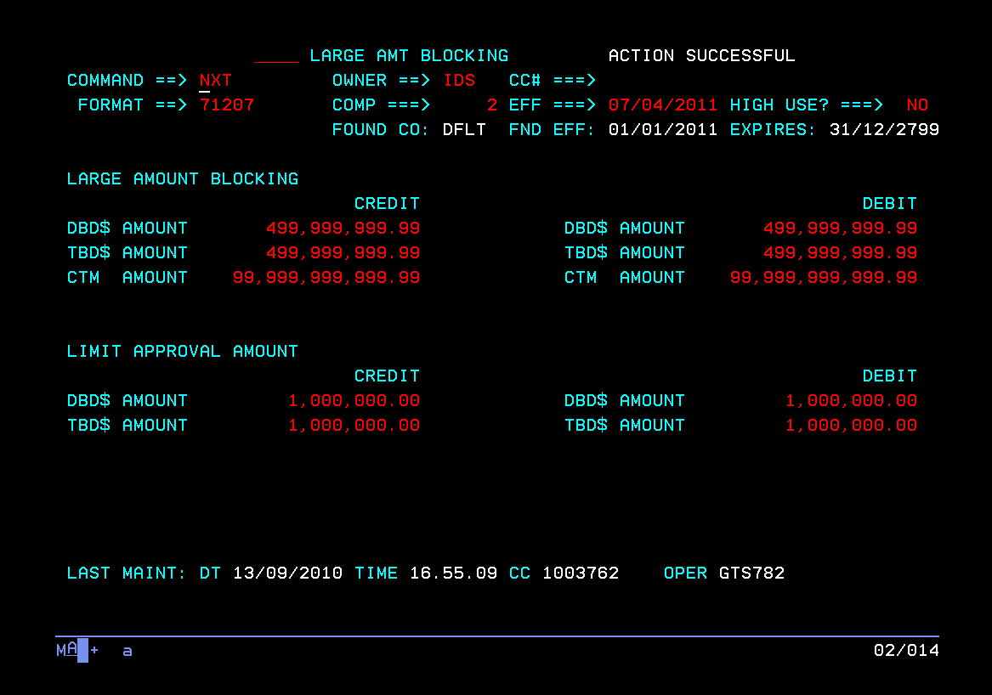
Figure 8A – PCD 71207 Large Amount Blocking
- As displayed in figure 8A, there is no batch limit on CACHE for processing transactions via CTM. CACHE is able to cater for uncleared funds and therefore risk of paying against large batch transactions is reduced.

Screens

Screen References

Screen ID | Screen Name | Brief Description | Document Link
OTPR | OTP Monetary With Float | Displays rejected transactions for both Value and Non-value | PVCS/CACHE_ORION/Baseline Documentation/BFS/CACHE SCREENS MANUAL.doc
DD18 | DDA Float Adjustment | Used to adjust Float (Uncleared Funds) on an account | PVCS/CACHE_ORION/Baseline Documentation/ BFS/CACHE SCREENS MANUAL.doc
THFR/Option 02 | THF Transaction History Inquiry | Displays list of transactions for DDA account | PVCS/CACHE_ORION/Baseline Documentation/ BFS/CACHE SCREENS MANUAL.doc
THFR/Option 03 | THF Statement Format Inquiry | Displays list of transactions for DDA account in Statement Inquiry format | PVCS/CACHE_ORION/Baseline Documentation/ BFS/CACHE SCREENS MANUAL.doc
THFR/SDET | THF Single Trans Detail INQ | Displays the details of a particular transaction on a DDA account | PVCS/CACHE_ORION/Baseline Documentation/ BFS/CACHE SCREENS MANUAL.doc
ABAL | HISS Available BAL INQ | Displays the CACHE Available Balance for CACHE Accounts | PVCS/CACHE_ORION/Baseline Documentation/ BFS/CACHE SCREENS MANUAL.doc
DBD$ | IDS DDA Online Transaction | Screen used to process transactions online in CACHE | PVCS/CACHE_ORION/Baseline Documentation/ BFS/CACHE SCREENS MANUAL.doc

Screen Flow Diagram
No Applicable

Letters / Notices

Letter / Notice References
Letter / Notice ID | Letter / Notice Name | Brief Description | Online/Batch | Brief Description | Document Link
N/A

Letter / Notice Flow Diagram
No Applicable to Payment Processing

Reports

Report References

Report ID | Report Name | Brief Description | Document Link
XP5133 | Daily Refer List | Reports accounts that are out of order or irregular | PVCS/CACHE_ORION/Baseline Documentation/CACHE/CACHE Reports BFS.doc
XP5146 | Weekly Status Report | Reports all Current Accounts, Term Deposits, Loan Accounts, Cash Advance Accounts (CAA), Liability Accounts and INC/RI accounts for each customer group controlled by the Account Manager. | PVCS/CACHE_ORION/Baseline Documentation/CACHE/CACHE Reports BFS.doc
XP5147 | Group Balances Report | Reports group customers' current accounts, Cash Advance Accounts (CAA) including INC/RI accounts, regardless of whether the account operated. | PVCS/CACHE_ORION/Baseline Documentation/CACHE/CACHE Reports BFS.doc
CR5149 | Transaction Posting Journal | Reports all value transactions posted to current accounts. Also reports all non-value Float adjustments performed via DD18 screen. | PVCS/CACHE_ORION/Baseline Documentation/CACHE/CACHE Reports BFS.doc
CR5225 | Online Transaction Posting Journal | Reports value transactions posted on-line through DBD$ & DD17 screen. Also reports all non-value Float adjustments performed via DD18 screen. | PVCS/CACHE_ORION/Baseline Documentation/CACHE/CACHE Reports BFS.doc

PCD / Parameter Tables

PCD / Parameter Table References

PCD / Parameter ID | PCD / Parameter Type | PCD / Parameter Name | Brief Description | Document Link
PCD71241 | Business Unit Uncleared Funds Tolerance Threshold | Business Unit Uncleared Funds Tolerance Threshold | Lists the Tolerance Threshold per Business Unit which is used for payment processing depending on OBP Code. | PVCS/CACHE_ORION/Baseline Documentation/BFS/PCD BFS.doc
PCD76006 | Officer Code PCD | Officer Data Alternate View of PCD1671 | Lists each Officer Code with contact details. Also lists what Business Unit and Cost Centre it is attached to | PVCS/CACHE_ORION/Baseline Documentation/BFS/PCD BFS.doc
PCD71207 | Large Amount Blocking | Large Amount Blocking | Used to control the $ value of transactions processed from both CTM and online via CACHE (DBD$) | PVCS/CACHE_ORION/Baseline Documentation/BFS/PCD BFS.doc
PCD1641 | Tran Code definition PCD | DDA/TDA Transaction Processing Criteria | Used to define tran codes used by CACHE during processing | PVCS/CACHE_ORION/Baseline Documentation/BFS/PCD BFS.doc

Interfaces

Online
Interface ID | Interface Type | Interface Name | Document Link
CTM | MQ Link
- CTM: Any time a value transaction is performed online in CACHE via DBD$ or DD17 screen, or when a non-value float adjustment is performed via DD18 screen, the details are sent to CTM real time via MQ Link. This ensures CTM have the most up to date Available Balance for the account.

Batch
Interface ID | Interface Type | Interface Name | Document Link
CTM | Batch Refresh File |  | PVCS/CACHE_ORION/Baseline Documentation/BFS/CACHE Interfaces BFS.doc
GIW | Batch Files |  | PVCS/CACHE_ORION/Baseline Documentation/BFS/CACHE Interfaces BFS.doc
ANZ Online (Tandem) | Batch Files |  | PVCS/CACHE_ORION/Baseline Documentation/BFS/CACHE Interfaces BFS.doc
ANZ Transactive | Batch Files |  | PVCS/CACHE_ORION/Baseline Documentation/BFS/CACHE Interfaces BFS.doc
- CTM: At the end of the CACHE nightly batch cycle, a refresh file is sent to CTM. The details sent in the refresh file include;
  - Ledger Balance
  - OD Limit
  - Total Float
  - Float per day
  - Float modifier (Tolerance Threshold)

- GIW: At the end of the CACHE nightly batch cycle, various files are created and send to GIW.
GIW files PAIW.SHR.ANZF.CMM.CACDDAA and PAIW.SHR.ANZF.CMM.CACDDAAS includes the following fields from CACHE which relate to Payment Processing;
  - Float Amount Days 0 - 5
  - Uncleared Funds Tolerance Threshold
  - Collected Balance
  - Available Balance
GIW file PAIW.SHR.ANZF.CMM.CACPCD includes the following PCD details from CACHE;
  - PCD71241
  - PCD76006
  - PCD1641
  - PCD71207
GIW file PAIW.SHR.ANZF.CMM.CACTXND includes all non-value transactions including Float adjustment transactions with tran codes 1228 & 1229. The following details are included;
  - Post Date
  - Tran Code
  - DR/CR (always F for float adjustments)
  - Transaction Amount
  - Aux Dom
  - GLI Code

- ANZ Online: At the end of the CACHE nightly batch cycle, a file is created and sent to ANZ Online. The details sent in this file relating to Payment Processing include;
  - Collected Balance
  - Uncleared Funds Tolerance Threshold based on OBP Code
  - Float Amount Days 1-4
  - Available Balance

- ANZ Transactive: At the end of the CACHE nightly batch cycle, a file is created and sent to ANZ Transactive. The details sent in this file relating to Payment Processing include;
  - Collected Balance
  - Uncleared Funds Tolerance Threshold based on OBP Code
  - Float Amount Days 1-4
  - Available Balance

Testing Considerations

Hints and Tips
The following is a list of testing considerations to consider when performing testing for payment processing;
Test Consideration # | Functions to be Considered
 | Test all non-value float transactions sent from CTM are processed as 1228 or 1229 transaction.
 | Test that the non-value float transactions created are included in the transaction history of the account.
 | Test that the non-value float transactions are reported in CR5149 Transaction Posting Journal.
 | Test that if a non-value float transaction is received from CTM has got multiple float day information, that it is processed as a single transaction but multiple days float are updated.
 | Test all value transactions sent from CTM are process as per current functionality.
 | Test all ledger and collected balances for balance history days 1 – 30 are populated correctly in DDMU/68.
 | Test all ledger and collected balances for balance history days 31 – 60 are populated correctly in DDMU/69.
 | Test all values for month-to-date balance information are populated correctly in DDMU/75 & 77.
 | Test that aggregate float amount is calculated correctly for DDMU/75 & 77.
 | Test all values for year-to-date balance information are populated correctly in DDMU/09.
 | Test float information of an account is displayed correctly in float adjustment screen DD18.
 | Test that when user selects DD18 option, the Float Adjustment screen is displayed.
 | Test that only users with authorized role can have access to DD18 Float Adjustment to maintain.
 | Test that for users not authorized to maintain float in DD18, an error message is displayed when attempting to do an action CHG.
 | Test that for users not authorized to maintain float in DD18, can perform an action INQ.
 | Test that when an adjustment is performed an appropriate non-value transaction item is created.
 | Test that posted adjustment items are included in the transaction history of the account.
 | Test that float items can be displayed in the Single Transaction Detail Inquiry.
 | Test that when an adjustment is performed, the float amount is reflected in their corresponding float day.
 | Test that adjustment transaction posted in DD18 is report in CR5225 Online Transaction Posting Journal.
 | Test that in DD18, the only valid ACTION is INQ and CHG and error message is displayed if anything else is entered.
 | Test that in DD18, when user performs inquiry on an account, system displays all relevant default account information.
 | Test that float transactions are added in PCD 1641.
 | Test RVTR action for reversal is prohibited in any transaction type ‘F’ for float.
 | Test that value for float fields are populated correctly in DDMU/06.
 | Test that uncollected balance is populated correctly in ABAL screen.
 | On DBD$ screen, test that the “CTM AVAILABLE BALANCE” field is populated with the up to date balance (before posting) from CTM when a transaction is processed.
 | On DBD$ and DD17 screen, When processing a debit transaction, test that the amount is checked against the Available Balance.
 | On DBD$ and DD17 screen, When processing a debit transaction, if the amount exceeds the Available Balance then test that an error message is displayed and the transaction is not processed.
 | When processing a debit transaction from CTM (including all payment channels) via CACHE Batch, test that the amount is checked against the relevant balance (Available/Collected/Ledger) depending on the OBP code.
 | When processing a debit transaction from CTM (including all payment channels) via CACHE Batch, if the transaction amount exceeds the relevant balance (Available/Collected/Ledger) then test that the transaction is rejected/posted depending on the OBP code.
 | When processing a debit transaction from CTM (including all payment channels) via CACHE Batch, test that for any transaction that is rejected, an entry is created in CACHE>OTP>NSFR and OTP Report SR0005.
 | When processing a debit transaction from CTM (including all payment channels) via CACHE Batch, test that for any transaction that is force-posted, an entry is created in CACHE>OTP>NSFR and OTP Report SR0005.
 | Test that appropriate items are posted as posted or unposted on SR 0005 OTP Input List Report for accounts with all OBP Codes.
 | Test that OBP Code defaults at sub product code level during account set up flow as defined in PCD 1600.
 | Test that account cannot be closed if Uncleared Funds are present in the account.
 | Test that new fields are added and correct values are displayed in Available Balance Inquiry Screen.
 | Test that Available Balance is calculated correctly.
 | Test that Uncleared Funds Tolerance Threshold cannot be loaded earlier than the next business date.
 | Test that updated Tolerance Threshold from PCD 71241 are sent to downstream applications on the batch day prior to the effective date.
 | Test that all accounts reporting to particular Business unit have access to the associated Uncleared Funds Tolerance Threshold amount.
 | Test that transaction details generated by using transaction code 1228 and 1229 are send to GIW.
 | Test that payment processing specific fields are sent to downstream applications namely ANZ Online, ANZ Transactive, and CTM.
 | Test value transactions post to accounts correctly.
 | Test that the value transactions are reported in CR5149 Transaction Posting Journal.
 | Test calculation of Available Balance works correctly.
 | Test that transaction history inquiry displays correct transactions as a result of payment processing.
 | Test that single transaction detail displays correct details as a result of payment processing.
 | Test that transaction reversal performs correctly.
 | Test that dishonour processing performs correctly.
 | On THFR screen, test Reversal of Transaction performs correctly via RVTR.
 | Test that OBP code can be maintained via DD01 screen.
 | Test that correct payoff balance is calculated.
Test the following reports display relevant data correctly:
SR0005,
CR5225,
CR5149.

Summary of Amendments
Additional amendments must be added after the previous amendment.
Date | Section | WR/AHD# | Implementation release and date | Author | Brief description of change
12/11/2012 | 1.2, 1.3, 4.1 & 6.1 | NA |  | J Kirk | Updated Links re PVCS & Sharepoint.

<Template Version and Administration>
The above title, this paragraph and all of the following must be deleted from the document prior to its publication for review.

Template Version History
Version | Release Date | Sections | Change Description | Author
0.1 | 13/10/2009 | N/A | Initial Revision | Kristina Vitkovski
0.2 | 11/01/2010 | N/A | ANZ Logo Updated | John Kirk

Contact Details
 Email any suggestions for improvement or comments about this template to the BFS Process Owner.

